Introduction
In September 2011 The School of Civil Engineering, Queen’s University Belfast was commissioned by Donite Plastics Ltd to test their ‘FlooddoorTM’ in accordance with British Standard PAS 1188-1:2009. The work was funded through an innovation voucher (reference number iv 0411027) from Invest Northern Ireland. This is the final report on the work in fulfilment with that contract.

Programme of work
The programme of work was specified as set out below.
Task 1 – Initial meeting with client, definition of the scope of work, advice on the design of the support rig to test the equipment, study the protocol for testing the equipment as specified by BSI.
Deliverables – methodology definition to conduct the test programme, review of support rig design to enable the client to manufacture the necessary equipment.
Task 2 – test the door for leakage around the seals in a static head of water up to 600mm for a duration of up to 48 hours.
Deliverables – report specifying test methodology, quantification of leakage and photographic record of test.
Task 3 – test for water tightness in a uniform steady flow of 1.0 m/s. This will be achieved by towing the specimen suspended underneath the deck of a catamaran specifically designed for towing objects in deep water.
Deliverables – report specifying test methodology, quantification of leakage and photographic record of test.
Task 4 – test of door water tightness in waves with a JONSWAP spectrum with significant wave height of 100mm and mean wave period of 1.03 s. for a time of 0.5 hours.
Deliverables – report specifying test methodology, quantification of leakage and photographic record of test.

Description of FlooddoorTM
FlooddoorTM is a product developed and manufactured by Donite Plastics Ltd in Northern Ireland. It is designed to prevent water ingress through doorways in buildings in the event of flooding. The door is manufactured in a variety of widths to suite different apertures from vacuum formed ABS plastic. It has a novel locking mechanism which both presses the FlooddoorTM down to compress the seal onto the bottom step of the doorway while at the same time forcing the FlooddoorTM back compressing the vertical seal against the door frame. The general arrangement of the FlooddoorTM is shown in figures 1 and 2 below. The locking mechanism is very simple and effective. Two stainless steel studs protrude from each of the vertical sides of the FlooddoorTM. These are connected to vertical rods within the edges of the FlooddoorTM which are pulled up by over centre handles on the top of the unit. The studs engage with shaped recesses in plastic block which are attached to the door frame around the aperture to be sealed. Details of the locking mechanism are covered in patent application number 1108251.8.

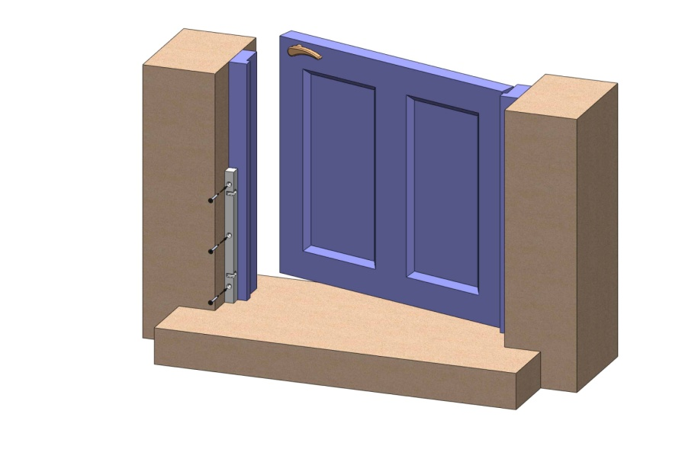

Figure 1 attachment blocks on door frame
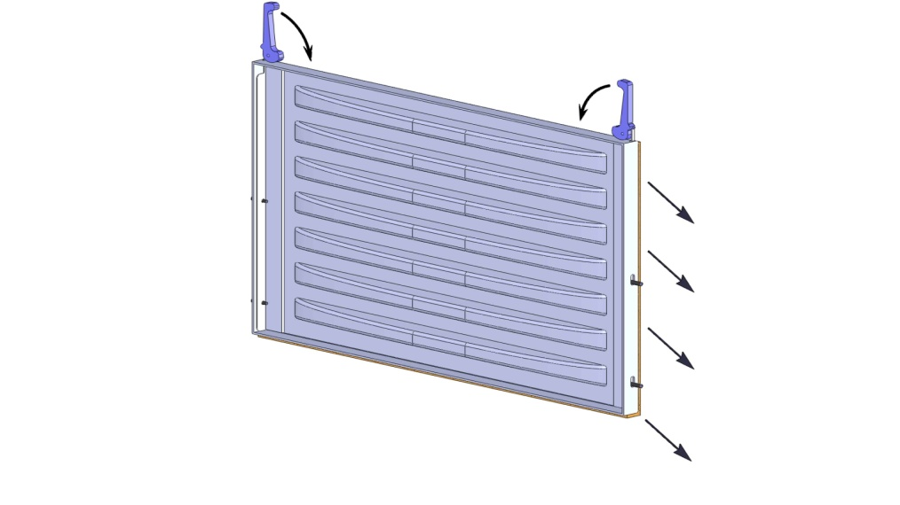

Figure 2 FlooddoorTM panel

Test methodology
BSI British Standards PAS 1188-1:2009 ‘Flood Protection Products- Specification Part 1: Building aperture products’ specifies a methodology for testing such devices. There are three types of test,
- Static water test
- Moving water test
- Wave test
In all tests any movement of the FlooddoorTM was checked by noting the position of the unit before and after as well as an extensive photographic record and observation of any deformation of the specimen.
Test facility
The FlooddoorTM tested is the widest unit produced by the company and is 920mm wide to fit in front of a door aperture 890mm wide.A purpose designed test cell was built to replicate the door step and door frame of a typical building. Shown in figure 3, this comprised a surrounding steel frame housing a concrete door step at the bottom, a wooden door frame at both sides, an acrylic sheet to the rear and attachment brackets. When the FlooddoorTM was installed into the door frame and door step a watertight chamber was created 100mm wide. The cell was designed so that any water leaking into the cell could be pumped out into a measuring cylinder at time intervals determined by the rate of leakage. During the wave and current tests the gap above the FlooddoorTM was sealed with clear sheeting and waterproof tape to prevent water ingress due to splashing. This was permissible under the BS code.
Figure 3 test cell

Static water test (task 2)
Both the static water tests and the wave tests were conducted in the wave tank facility in the David Keir Building in the Civil Engineering department of Queen’s University. In these tests the designated maximum water depth (DMWD) was specified as 600mm from the doorstep.
- Initially the wave tank was filled so that the water level was 200mm up the FlooddoorTM which was 1/3 DMWD. The specimen was allowed to sit for 1 hour and any leakage measured.
- The water level was increased to 400mm or 2/3 DMWD and the door was allowed to sit for one hour.
- The water level was then increased to 600mm or DMWD and the door allowed to sit for 18 hours.
- Finally the above tests were repeated again but in the last test the door was allowed to sit for 48 hours.
Static water test results
In all the static water tests there was absolutely no leakage at any time. Removing the FlooddoorTM , reinstalling it and repeating the tests did not cause any leakage.

Current test (task 3)
The hydraulics laboratory at Queen’s does not have a flow facility for testing FlooddoorTM in a steady current of 1m/s. Instead the test cell with FlooddoorTM installed was towed at constant seed in a still water lake. This part of the work was subcontracted to Wavebarrier Ltd. as they have access to a private lake (Mongomenry lake near Ballynahinch) and have a 16m long 6m wide catamaran . The test cell was mounted off the cross beams between the hulls . The general setup for this test is shown in figure 4.
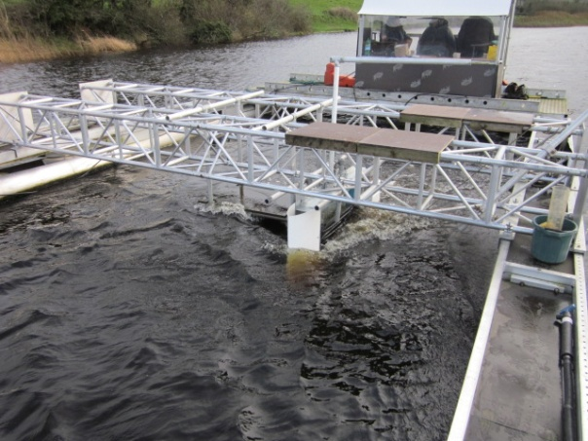
Figure 4 Test cell being towed by catamaran in Montgomery Lake
As the DMWD for FlooddoorTM was 600mm table B1 in the BS code states that the depth for current testing is 500mm. In order to ensure that the water flow was in contact with both vertical edges of FlooddoorTM a fairing was attached to the leading face of the test cell to ensure that the flow did not separate and create a tube vortex down the leading vertical seal.
- The test cell with FlooddoorTM installed was towed at a constant speed of 1m/s for one hour and any water ingress was measured.
- FlooddoorTM was then removed and reinstalled and the test repeated for one further hour and any water ingress measured.
- Although the above test are all that are specified in the BS code a further test was conducted at 2m/s. FlooddoorTM was removed and reinstalled and then towed for a further hour. Again any water ingress was measured.
Photographs of the various towing tests are shown in figures 5,6 and 7.
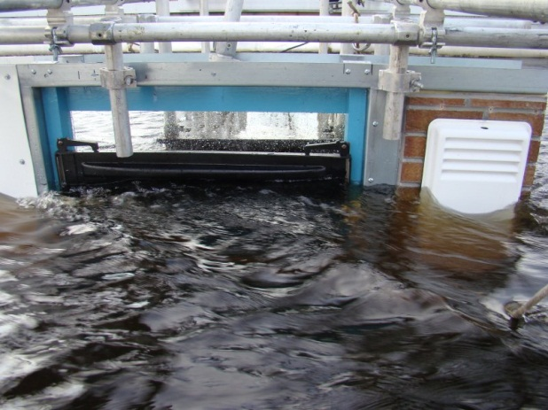 | 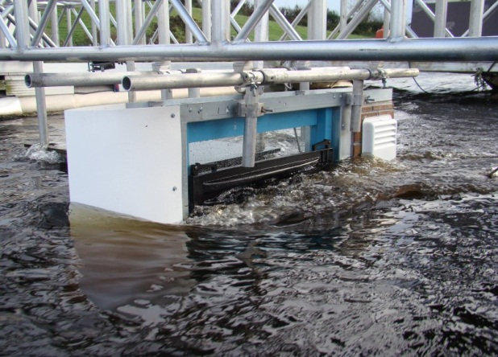
Figure 5, 6 FlooddoorTM in test cell being towed by the catamaran
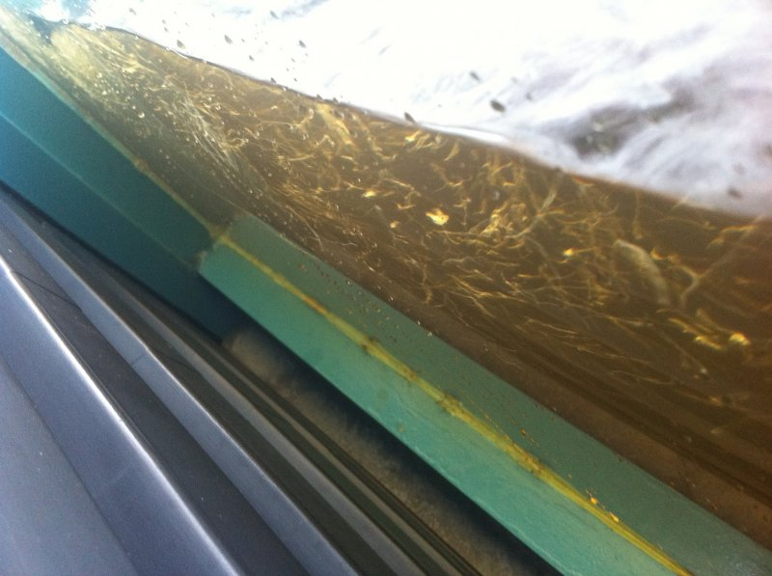
Figure 7looking down into the test cell with FlooddoorTM to the left and the window to the right

Towing/ current test results.
Again there was absolutely no leakage into the test cell during all of these tests including the double speed test. However, it was noted that FlooddoorTM deflected 4mm at mid span during the tests.
Wave test (task 4)
The BS code specified that a door with the DMWD depth of 600mm should be tested in waves at a depth of 450mm. The wave condition specified is a JONSWAP spectrum with a significant wave height of 100mm and mean wave period of 1.03s. This was applied perpendicular to the face of FlooddoorTM. Initially the paddles in the Queen’s University Civil Engineering wave tank had to be programmed to produce a sea of the above specification. The wave paddle computer has software to do this but it still required calibration and three iterations to get the required sea. Arrays of wave measurement probes were located at the position where the test cell was to be installed and the sea calibrated at that location. Figure 8 shows the wave spectrum used.
The test cell was then bolted to the floor of the tank with additional upper support from transverse beams above. In order to prevent water ingress into the test cell above FlooddoorTM clear plastic sheeting was taped in place to seal the gap up to the frame of the test cell. The wave test was conducted twice for a period of 30 minutes each. Between the tests FlooddoorTM was removed and re-installed. Figure 9 shows FlooddoorTM in the test cell being subjected to the designated wave spectrum.
Results from wave tests
FlooddoorTM did not leak in either of the wave tests.
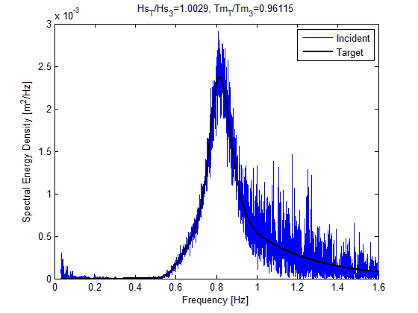
Figure 8 Wave spectrum used in the tests showing target and achieved. | Figure 9 Wave test on FlooddoorTM

Conclusions
In all the tests conducted on FlooddoorTM there was no leakage around the seals next to the door frame and the concrete step. FlooddoorTM was fast to both install and remove. Installation did not require adjustment to make it seal perfectly every time.

Therefore FlooddoorTM has successfully passed an equivalent set of tests to those specified in British Standard PAS 1188-1:2009.

References
BSI British Standards, Flood protection products – specification Part 1; Building aperture products,
PAS 1188-1:2009

